Bredbury St Mark’s CE Primary School

Religious Education
Policy

‘With God all things are possible’ Matthew 19:26
It is this belief in us from God that will enable us to dream, believe and achieve

Our six key values we embrace are:
Hope, Perseverance, Courage, Love, Friendship and Forgiveness

Review Date | By Whom
Written 2024 | RE Leader
Review Oct 2024- to include right to withdraw | RE leader and Headteacher
Review Date Autumn 2025 | RE Leader

School Vision Statement
Aims
- At Bredbury St Mark’s we align our school vision with that of the Chester Diocese Academy Trust with the promise that we want every child to experience ‘life in all its fullness.’ (John 10:10)
- Our vision is supported through our school motto DREAM BIG. We believe in the capabilities of all and that dreams can be turned into reality.
- We endeavour to inspire and motivate everyone to be the best that they can be, growing and learning in a community inspired by Christian values.

Our chosen key Christian values contribute towards achieving our vision.
Hope, Perseverance, Courage, Love, Friendship and Forgiveness

- We aspire to equip everyone with the skills needed to believe they can achieve and to reach their goals. Our school is a safe, happy and welcoming place where every child’s uniqueness is valued and supported.
- Working together with our community, we will develop happy children who can succeed in the modern world with their enquiring minds, spirit of curiosity, respect for themselves, others and the environment and having the skills, resilience and adaptability to thrive.

Why is RE important at Bredbury St Mark’s?
- As a Church of England School, we believe that RE is an important core curriculum subject and is embed in our school beliefs and values through our Christian Ethos.
- Our school motto – “Dream Big” to reflect our vision that is ‘With God all things are possible’ Matthew 19:26. Our Christian Ethos is at the centre of everything we do and we help the children to grow and develop through our 6 Main Values: Love, Hope, Forgiveness, Friendship, Perseverance and Courage.
- It is important for all Children to know they are cared for and loved, and can achieve anything they want to in life with the belief and support of God and the staff at Bredbury St Mark’s.
- Through RE, our children are able to deepen their understanding about not only Christianity but other World Faiths and religion and those who might not have a faith.
- Our choice of Religions to teach reflects the fact that the religious traditions in Great Britain are mainly Christian- while taking account of the teaching and practices of the other principal religions represented in Great Britain. We have families, adults and children in our school community whose beliefs and practices reflect the other principal religions apart from Christianity. We also recognise that there are members of the school community that do not have any religion, so in UKS2 children learn about Humanism. Legally school are required to recognise diverse religions and systems of belief in the UK both locally and nationally and we feel we have met this with the coverage of religions we teach.
- We strive to ensure that our children are equipped with the skills needed to meet the challenges of our ever-changing world and make their own positive contributions to our global society.

The Curriculum Aims and overview

At Bredbury St Mark’s we follow the Stockport Agreed Syllabus for Religious Eduction (2022-2027). https://www.trafford.gov.uk/residents/schools/SACRE/docs/MSSTT-Agreed-Syllabus-for-Religious-Education.pdf

Principal aim of the SACRE MSSTT Agreed Syllabus
The principal aim of RE is to engage pupils in systematic enquiry into significant human questions which religion and worldviews address, so that they can develop the understanding and skills needed to appreciate and appraise varied responses to these questions, as well as develop responses of their own. Each unit has a core questions for each year group linked to the theme/concept taught that half term.

The aim(s) of RE
The threefold aim of RE elaborates the principal aim.

The curriculum for RE aims to ensure that all pupils:
- Know about and understand a range of religious and non-religious worldviews1, so that they can:
- describe, explain and analyse beliefs and practices, recognising the diversity which exists within and between communities and amongst individuals.
- identify, investigate and respond to questions posed, and responses offered, by some of the sources of wisdom found in religious and non-religious worldviews.
- appreciate and appraise the nature, significance and impact of different ways of life and ways of expressing meaning.

- Express ideas and insights about the nature, significance and impact of religious and non-religious worldviews, so that they can:
- explain, using reasoned arguments, their ideas about how beliefs, practices and forms of expression influence individuals and communities
- express with increasing discernment their personal reflections and critical responses to questions and teachings about identity, diversity, meaning and value, including ethical issues
- appreciate and appraise varied dimensions of religion.

- Gain and deploy the skills needed to engage seriously with religious and non-religious worldviews, so that they can:
- investigate key concepts and questions of belonging, meaning, purpose and truth, responding creatively.
- enquire into what enables different individuals and communities to live together respectfully for the wellbeing of all.
- articulate clearly beliefs, values and commitments in order to explain why they may be important in their own and other people’s lives.

What religions and worldviews are to be taught?
This agreed syllabus requires that all pupils study Christianity in each key stage. In addition, pupils will study the principal religions represented in the UK, in line with the law. These are Islam, Hindu dharma and Judaism. Furthermore, children from families where non-religious worldviews are held are represented in almost all our classrooms. Non-religious worldviews, including ‘organised’ examples such as Humanism, will also be the focus for study.
Religious traditions are to be studied in depth as follows:
4–5s  Reception | Children will encounter Christians and people of other faiths, as part of their growing sense of self, their own community and their place within it.
5–7s  Key Stage 1 | Christians and Muslims or Jewish people
7–11s  Key Stage 2 | Christians, Muslims, Hindus and Jewish people  In KS2 they will also look at Humanism

How and when is RE taught at Bredbury St Mark’s?
At Bredbury St Mark’s RE is taught each week on the same afternoons (Monday or Tuesday). Every year group has a timetabled 1-hour slot, however we believe in being flexible with how this hour is used. One-week children may take part in a longer RE session due to the knowledge and activities delivered. The week after they may only have a shorter session. EYFS have the equivalent of 50min- 1-hour session, however due to the nature of learning in the early year setting this hour may be split into shorter sessions across the week at the teachers discretion to suit the learning of the children in their class.
We also supplement our RE teaching with themed weeks and day throughout the year. For Example- Easter Week, Christmas week, World Religion Day etc.
The Sacre MTTSS agreed syllabus is structure to cover 3 main areas of learning which the children build on throughout the year and from year-to-year through key questions: Believing, Religious beliefs, teachings, sources; questions about meaning, purpose and truth; Expressing, Religious and spiritual forms of expression; questions about identity and diversity; and Living, Religious practices and ways of living; questions about values and commitments.

Below is the overview of questions cover in each Key Stage:
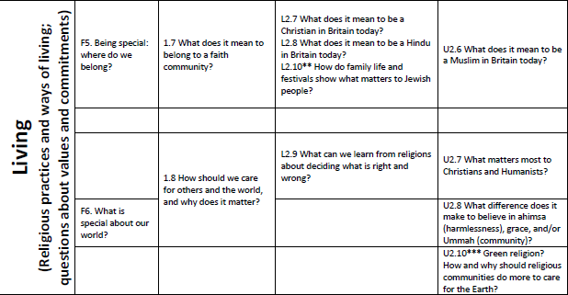
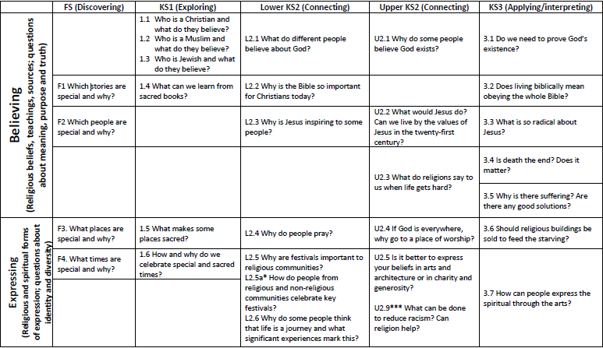

Long Term Plan
RE Long Term Plan 2024/2025 | Believing  (Religious beliefs, teachings, sources; questions about meaning, purpose and truth) |  | Expressing  (Religious and spiritual forms of expressions; questions about indemnity and diversity) |  | Living  (Religious practices and ways of living; questions about values and commitments)
 | Autumn 1 | Autumn 2 | Spring 1 | Spring 2 | Summer 1 | Summer 2
EYFS | F1. Which stories are special and why? | F2. Which people are special and why? | F3. What places are special and why? | F4. What times are special and why? | F5. Being special: where do we belong? | F6. What is special about our world?
Year 1  Christians Jewish People | 1.1 Who is a Christian and what do they believe? | 1.3 Who is Jewish and what do they believe? | 1.4 What can we learn from sacred books?  (Christians and Jewish People) | 1.5 What makes some places sacred?  (Christians and Jewish People) | 1.6 How and why do we celebrate special and sacred times?  (Christians and Jewish People) | 1.7 What does it mean to belong to a faith community?  (Christians and Jewish People)
Year 2  Christians Muslims  (Recap) Jewish People | 1.1 Who is a Christian and what do they believe?  1.3 Who is Jewish and what do they believe?  RECAP | 1.2 Who is a Muslim and what do they believe? | 1.4 What can we learn from sacred books? | 1.5 What makes some places sacred? | 1.6 How and why do we celebrate special and sacred times? | 1.8 How should we care for others and the world, and why does it matter?
 | In Year 2 |  | New Learning- Muslims and compare back to work done last year on Christians and Jewish People
Year 3  Christians  Muslims Jewish People | L2.1 What do different people believe about God?  (Christians and Muslims) | L2.2 Why is the Bible so important for Christians today? | L2.4 Why do people pray?  (Christians and Muslims) | L2.7 What does it mean to be a Christian in Britain today? | L2.5 Why are festivals important to religious communities?  (Christians and Jewish People) | L2.10 How do family life and festivals show what matters to Jewish People?
Y4/5  Christians  Hindus  Humanists  (Jewish recap) | U2.1 Why do some people believe God exists?  (Christians and Humanists) | U2.4 If God is everywhere, why go to a place of worship?  (Christians and Jewish people) | U2.2 What would Jesus do?  (Can we live by the values of Jesus in the twenty-first century?) | L2.8 What does it mean to be a Hindu in Britain today? | L2.6 Why do some people think that life is a journey and what significant experiences mark this?  (Christians, Hindus, and Humanists) | L2.9 What can we learn from religions about deciding what is right and wrong?  (Christians, Jewish people, and Humanists)
Y5/6  Christians  Muslims  Humanists  Hindus | U2.3 What do religions say to us when life gets hard?  (Christians, Hindus and Humanists) | U2.4 If God is everywhere, why go to a place of worship?  (Christians and Hindus) | U2.7 What matters most to Christians and Humanists? | U2.6 What does it mean to be a Muslim in Britain today? | U2.8 What difference does it make to believe in ahimsa (harmlessness), grace, and/or Ummah (community)?  (Christians and Muslims) | U2.9 What can be done to reduce racism? Can religion help? (Christians, Muslims and non-religious)

Assessment
During RE both formative and summative assessments are use. Teachers monitor the children’s understanding though questions and discussions during class and assess them each lesson against the learning objective taught. At the end of the unit the teacher will often then ask the children to complete a task to assess their understanding of the topic as a whole. These can be a written piece, a visual picture with annotated, discussion and though questioning depending on the age of the children and topic that has been covered. The teacher will then use this piece of work to assess again the outcomes of the topic as well as any other learning and conversations they have see/had throughout the unit.
After the unit has been completed teacher will fill out an assessment sheet.
This requires them to plot the children against the learning outcomes for the unit and assess the children as either emerging, expected or exceeding against key statements.
They will then need to explain certain children maybe emerging and what can be done to support them in the future. The document also requires the teacher to think about implications for the future through 2 additional questions:
- Implication and actions for future topics this year
- Implications for Future topics in following year

Right of withdrawal
Parents / Carers are advised that they have the right to withdraw their child from Religious Education and the Act of Worship and are not required to provide a reason for doing so.
They will be encouraged to discuss their decision with the headteacher following a request to withdraw their child in terms of:
- The elements of worship the parent /carer would object to their child taking part in
- The practical implications of withdrawal.
- Whether the parent / carer will require notice in advance of such worship, and if so, what period of notice is preferred.

