Bredbury St Mark’s CE Primary School
Spiritual, Moral, Social and Cultural Policy

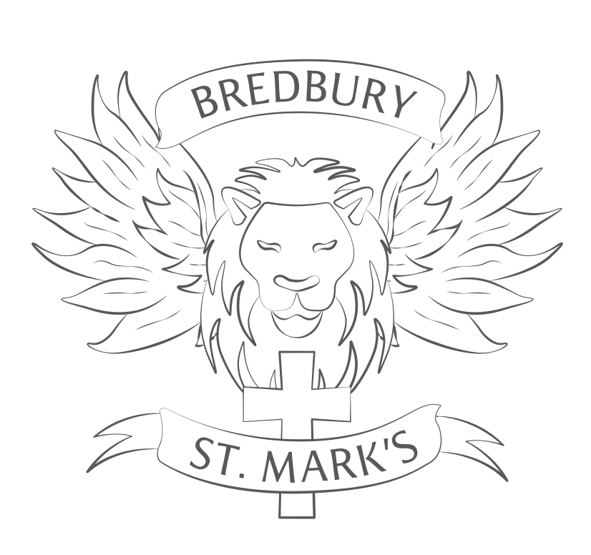

Approved by LGB: October 24
Review Date: October 26

Spiritual, Moral, Social and Cultural Development in School

Bredbury St Mark’s CE Primary Vision statement says:
‘With God all things are possible’ Matthew 19:26
It is this belief in us from God that will enable us to dream, believe and achieve
- At Bredbury St Mark’s we align our school vision with that of the Chester Diocese Academy Trust with the promise that we want every child to experience ‘life in all its fullness.’ (John 10:10)
- Our vision is supported through our school motto DREAM BIG. We believe in the capabilities of all and that dreams can be turned into reality.
- We endeavour to inspire and motivate everyone to be the best that they can be, growing and learning in a community inspired by Christian values.
Our chosen key Christian values contribute towards achieving our vision.
Hope, Perseverance, Courage, Love, Friendship and Forgiveness
- We aspire to equip everyone with the skills needed to believe they can achieve and to reach their goals. Our school is a safe, happy and welcoming place where every child’s uniqueness is valued and supported.
- Working together with our community, we will develop happy children who can succeed in the modern world with their enquiring minds, spirit of curiosity, respect for themselves, others and the environment and having the skills, resilience and adaptability to thrive.
This policy is intended to underpin our school’s vision statement and ethos.
Spiritual Development
Spiritual development enables people to look within themselves at their human relationships, at the wider world. The spiritual development of all our children is addressed through the ethos of the school.
As a church school we include Christian spiritual practices including, prayer, worship, celebration of festivals and reading/reflection on the Bible within Collective Worship, RE and the wider curriculum.
We are committed to:
- celebrating the religious and non-religious beliefs and values that our pupils bring as part of their family/culture heritage;
- building an awareness of and respect for others’ spiritual and religious beliefs;
- fostering common human values and building spiritual capacities to promote self-esteem and a valuing of others;
- helping our pupils to come to an understanding of themselves as unique individuals and encouraging them to reflect on the meaning of our experiences;
- developing personal views and insights;
- stimulating our pupils’ curiosity, imagination, creativity and promoting a sense of awe and wonder.

At St. Mark’s children will be given opportunities to develop these qualities both in and out of the classroom.
Moral development
Moral development: knowing what is right and wrong and acting on it accordingly. We are committed to encouraging pupils to:
- be truthful and honest;
- respect the rights and property of others, their opinions and customs, even when they are different from our own;
- take responsibility for their own decisions and actions;
- begin to recognise the moral dilemma in situations;
- develop for themselves guidelines to govern their own behaviour
- behave well consistently
- articulate their own attitudes and values;
- solve differences of opinion in non-violent ways.
Consequently, we reject all forms of bullying, cruelty, dishonesty, violence and discrimination.
Social development
Social development: developing an understanding of rights and responsibilities of living in a community – of being a “responsible citizen”. We are committed to:
- fostering the skill and qualities of team building through the development of self-confidence, co-operation, sensitivity to others, reliability, initiative and understanding;
- providing an environment where pupils can take responsibility for themselves and others in school and the wider society;
- encouraging the children’s growing understanding of society through the family, the school, the church and local and wider communities
We use the social and emotion aspects of learning (SEAL) programme to support our pupils’ social development
Cultural development
Cultural development: knowledge and understanding of others’ cultural traditions. We value and celebrate the cultural diversity of our school, our society and the world by:
- promoting an appreciation of our own cultural traditions and encouraging an appreciation of other peoples’ cultural traditions;
- encouraging children’s responses through art, literature, music, dance etc.;
- celebrating the richness of culture and tradition.

In the light of this we will ensure that the SMSC development of our pupils is promoted across the curriculum and in the wider life of the school by:
- providing an appropriate range of effective teaching and learning strategies that enables pupils to reflect on and respond to the issues of SMSC importance and concern;
- maintain a positive climate in school in which all are valued and respected and expected to make a positive contribution;
- encouraging teachers to plan for and respond to opportunities to develop SMSC development and to ensure subject leader have an understanding of SMSC education in their subject;
- recognising the importance of our collective worship programme in supporting and encouraging SMSC development.

The following policies are closely linked with this policy:
Special Educational Needs and Disability Policy
Equality and Diversity
Collective Worship Policy
Relationship Policy
Anti-Bullying Policy
Subject area policies especially, but not exclusively, RE, PSHE

