Dear parents/carers,

As some of you may know, during the last school year we had some wonderful volunteers who helped to organise and resource our school library. This means that we can now start using it – and allowing children to borrow books!

Each week, every class will have an allocated library session. This may involve them spending sometime enjoying a book by themselves, with a friend or as a class. During these sessions, the children will have the opportunity to choose library books to take away with them.

Each child will be issued with a library card that will keep track of the books that they have borrowed. These cards will stay in school and the adults in your child’s class will sign their books in and out. As you can appreciate, a lot of time and effort has been put into the library and we really want to keep it as fully stocked as possible, so children will not be able to take a new book out until the previous one has been returned.

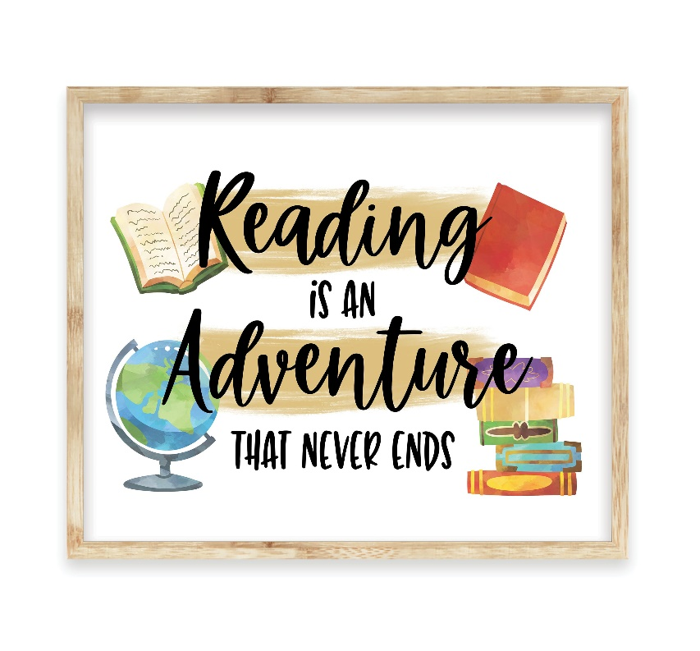

Children are welcome to take their library books home with them and share them with yourselves and other family members, but please can you make sure that the books are looked after and returned in the same condition that they came home in.

We appreciate your support with this and are excited to promote a love of reading amongst our wonderful children.

Kind regards,

Mrs Bebbington

(English subject co-ordinator)