 | Autumn Term – Year 6
 | Autumn 1 | Autumn 2
 | Writing skills focus:  - Use the correct tense throughout a piece of writing.  - Use modal verbs appropriately to suggest degrees of possibility. | Writing skills focus:  - Add precision, detail and qualification using prepositional phrases and adverbs.  - Effectively draft work to enhance meaning and adapt grammar choice for effect.  Use colons, semi-colons, hyphens
 | Genre focus  Fiction: Stories with historical settings  Non-fiction: Recount  Poetry: | Genre focus  Fiction: Stories with historical settings  Non-fiction: Newspaper report  Poetry: Creating images
Core text | The Harmonica Rose Blanche Erika’s story  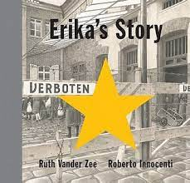  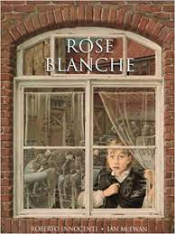  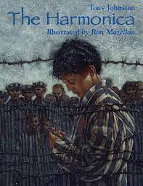 | Anne Frank  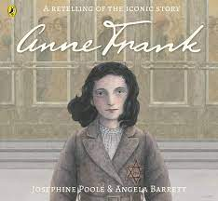
Fiction | Stories with historical settings  (Writing a range of pieces with a focus on the above books)  Flashbacks, character profiles, contrasting characters | Stories with historical settings  Setting description writing
Non-fiction | Recount | Newspaper report
Poetry |  | Creating images – life during the war
Hook ideas

Short burst writing opportunities | Letters  Postcards  Debates  Diaries | Letters  Diaries  Obituaries
Texts to enrich learning

Wider curriculum writing opportunities (if apt)
Bredbury 50 things links

 | Spring Term – Year 6
 | Spring 1 | Spring 2
Writing skills focus:
- Adapt the grammar and vocab in my writing to suit the audience
- Use antonyms and synonyms to enhance description
- Describe and integrate dialogue to convey character and move the action along.
- Use a range of cohesive devices (adverbials, pronouns, conjunctions, similes, ed/ing/ly, repetition, prepositional phrases, ellipses
- Use relative clauses, embedded clauses, subordinate and coordinating clauses, adverbials, prepositional clauses
- Formal speech
- Use colons, semi-colons, hypens
Genre focus
Fiction: Author study – William Shakespeare
Non-fiction: Range of writing opps
Poetry: Poetic style – spells
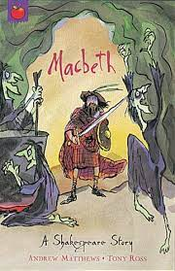
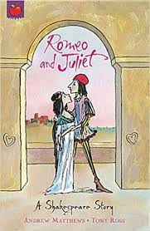

Core text | Stories by William Shakespeare  (Romeo and Juliet, Macbeth)
Fiction | Playscripts
Non-fiction | See below
Poetry | Poetic style (spells)
Hook ideas
Short burst writing opportunities | Newspaper report  Diary entry  Letters  Instructions  Biographies  Persuasion  Argument
Texts to enrich learning

Wider curriculum writing opportunities (if apt)
Bredbury 50 things links

 | Summer Term – Year 6
 | Summer 1 | Summer 2
 | Writing skills focus:  - Use colons, semi-colons, hyphens  - Re-draft work to show thoughtful and effective changes to impact the reader  - Proof read work accurately | Writing skills focus:  - Modal verbs to argue (possibility, probability and certainty)
 | Genre focus  Fiction: Film narrative  Non-fiction: Debate/Argument | Genre focus  Fiction:  Non-fiction: Persuasive advert
Core text | 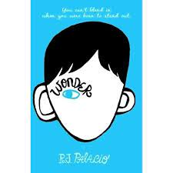  Wonder
Fiction | Film narrative (The little freak on Literacy shed)
Non-fiction | Argument/debate | Persuasive advert – Holiday Brochure
Poetry
Hook ideas

Short burst writing opportunities | Charatcer descriptions  Emotions  Monologue  Diary entry | Descriptions  Persuasive language  TV advert
Texts to enrich learning

Wider curriculum writing opportunities (if apt)
Bredbury 50 things links

