 | Autumn Term – Year 1
 | Autumn 1 | Autumn 2
 | Writing skills focus:  - Leave spaces between words  - Use a capital letter | Writing skills focus:  - Holding a sentence - ‘Say a sentence out loud before writing it down’  - Using the personal pronoun ‘I’
 | Genre focus  Fiction: Fairy tales  Non-fiction: Letters | Genre focus  Fiction: Stories with familiar settings  Non-fiction: Recount  Poetry: Senses poetry
Core text | Little Red Riding Hood  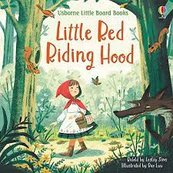 | 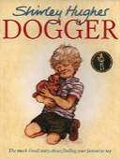  Dogger
Fiction | Fairytales – exploring traditional and twisted – create their own twist of a known fairytale | Stories with familiar settings
Non-fiction | Letters from the wolf  Reading age:  SPAG links: | Recount – writing about a time that they lost something
Poetry |  | Sense Poetry (Bonfire Night)7
Hook ideas

Short burst writing opportunities | -Character descriptions (contrasting good and bad)  -Predict the ending  -Compare versions  -Recount | -Setting description (different familiar settings)  -Exploring adjectives  -Lost poster  -Draw + label lost object  -Compare different familiar settings
Texts to enrich learning

Wider curriculum writing opportunities (if apt)
Bredbury 50 things links

 | Spring Term – Year 1
 | Spring 1 | Spring 2
 | Writing skills focus:  - Plan my writing by talking about what I am going to write about.  - Read own word out loud so it can be heard by others to check it makes sense. | Writing skills focus:  - Use ‘and’ to join ideas within a sentence  - Use other punctuation such as exclamation and question marks.  - Accurately use a full stop.
Genre focus
Fiction: Oliver Jeffers
Non-fiction: Information text
Poetry: Silly Poems
Core text | Books by Oliver Jeffers Fantastic first poems  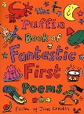  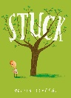  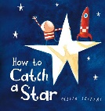  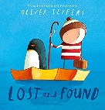  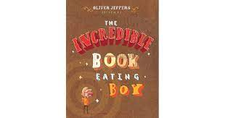
Fiction | Different stories by the same author  Reading age:  SPAG links:
Non-fiction | Information text – Fact file about Oliver Jeffers and book reviews about 4 books read.  Reading age:  SPAG links:
Poetry | Silly poems  SPAG links:
Hook ideas

Short burst writing opportunities | -Character/setting descriptions  -Postcards  -Letters  -Captions  -Message in a bottle  -Lists
Texts to enrich learning

Wider curriculum writing opportunities (if apt)
Bredbury 50 things links

 | Summer Term – Year 1
 | Summer 1 | Summer 2
 | Writing skills focus:  - Attempt to use other conjunctions  - Use word banks relevant to the context  - Use adjectives to add detail to my sentences | Writing skills focus:  - Use sequence sentences to form short narratives  - Use sequence sentences in chronological order to recount experiences
 | Genre focus  Fiction: Fantasy Worlds  Non-fiction: Non-chron report | Genre focus  Fiction: Stories from other cultures  Non-fiction: Fact files  Poetry: Poems on a theme
Core text | Where the wild things are  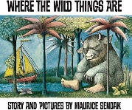 | Greatest animal stories  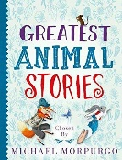
Fiction | Fantasy worlds – create their own fantasy worlds  Reading age:  SPAG links: | Stories from other cultures - Retell a fable
Non-fiction | Non-chron report – create own ‘wild thing’  Reading age:  SPAG links: | Fact file about animal
Poetry |  | Poems on a theme – animal poems: recreate a poem about an animal of their choice
Hook ideas

Short burst writing opportunities | -Setting description  -Character description  -Captions  -Exploring alliteration  -Phrases  -Speech bubbles | -Comparing fables  -Contrasting characters  -Labelling characters  -Classroom morals
Texts to enrich learning

Wider curriculum writing opportunities (if apt)
Bredbury 50 things links

