Dear parents/carers,
As we’re sure you are aware, World Book Day is fast approaching and this year we wanted to really celebrate our love of reading by having a whole school book theme that will last all week!
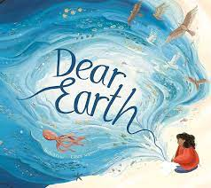
The book we will be focusing on is ‘Dear Earth’ By Isabel Otter. The book explores the beauty and wonders of our world whilst also discussing the ways in which our world is in danger.
If you would like to have a listen to the book, you can do so here:
https://www.youtube.com/watch?v=b2V8Ip3ldsI

To help celebrate the book, we are asking that on World Book Day, 7th March, the children come into school dressed as explorers or an animal. Please be as creative as you would like with the costumes – there is no expectation that you go out and buy something!
Please can I also remind you of the Reading Challenge we currently have running throughout the school. Please encourage your children to get their completed grids returned, to be in with a chance of winning that £25 voucher!
We thank you in advance for your support and enthusiasm with this event and we look forward to seeing some fantastic costumes.
Yours sincerely,
Mrs Bebbington
(English subject leader)

