 | Autumn Term – Year 3
 | Autumn 1 | Autumn 2
 | Writing skills focus:  - Write non-narrative using simple organisational devices (headings and sub-headings)  - Use a wider range of conjunctions to use sentences with more than one clause. | Writing skills focus:  - Begin to use inverted commas for some direct speech.  - Develop resolutions and endings in narrative writing.
 | Genre focus  Fiction: Good vs Bad  Non-fiction: Letters | Genre focus  Fiction: Fantasy story  Non-fiction: Information text
Core text | Hansel and Gretel  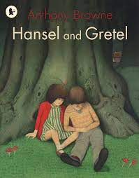 | The Boy who grew Dragons  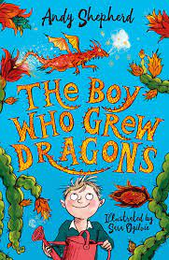
Fiction | Good vs Bad – write their own version of the story | Fantasy stories
Non-fiction | Letters | Information text
Poetry
Hook ideas

Short burst writing opportunities | Mood story using colour  Character profiling (good vs bad)  Meaning behind pictures  Exploring vocabulary | Chracter descriptions  Character profile  Setting description  Slow write  Poetry
Texts to enrich learning

Wider curriculum writing opportunities (if apt)
Bredbury 50 things links

 | Spring Term – Year 3
 | Spring 1 | Spring 2
 | Writing skills focus:  - Write consistently in one tense  - Use the perfect form of verbs.  - Understand and use adverbs.  - Use conjunctions, adverbs and prepositions. | Writing skills focus:  - Plan writing by discussing and recording ideas.  - Write a narrative with a clear structure, settings, characters and plot.  - Make improvements to writing through peer and self-assessment.  - Use apostrophes for possession (inc. plural possession)
 | Genre focus  Fiction: Adventure story  Non-fiction: Recount (diary entry)  Poetry: Classic narrative poems | Genre focus  Fiction: Suspense story  Non-fiction: Instruction text
Core text | The Diary of a killer cat The bee is not afraid of me  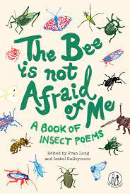  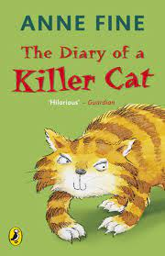 | 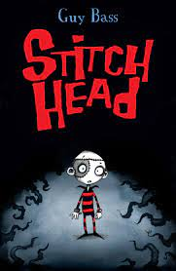  Stitch Head
Fiction | Adventure stroy | Suspense story – alternate ending
Non-fiction | Diary writing | Instruction text
Poetry | Classic narrative poems
Hook ideas

Short burst writing opportunities | Setting description  Change ‘normal’ sentences to suspense  Thoughts  Speech | Character description  Hot seating  Exploring openers  Diary writing  Alternate endings
Texts to enrich learning

Wider curriculum writing opportunities (if apt)
Bredbury 50 things links

 | Summer Term – Year 3
 | Summer 1 | Summer 2
 | Writing skills focus:  - Compose sentences using a wider range of structures (expanded noun phrases before and after the noun and use of adverbials).  - Commas to mark clauses and phrases | Writing skills focus:  - Organise paragraphs around a theme.
 | Genre focus  Fiction: Stories set in an imaginary world  Non-fiction: Newspaper reports  Poetry: Power of imagery | Genre focus  Fiction: Stories from other cultures  Non-fiction:  Poetry:
Core text | The nothing to see here hotel  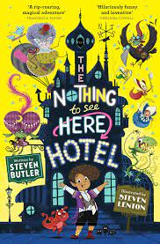
Fiction | Stories set in an imaginary world
Non-fiction | Newspaper reports
Poetry | Power of imagery  (World’s Greatest Space Cadet)
Hook ideas

Short burst writing opportunities | TV news headlines  Interviews  Diary  Postcards  Character descriptions
Texts to enrich learning

Wider curriculum writing opportunities (if apt)
Bredbury 50 things links

