 | Autumn Term – Year 4
 | Autumn 1 | Autumn 2
 | Writing skills focus:  - Narrative that is organised into clear sequences with more than a basic beginning, middle and end  - Open sentences in different ways. | Writing skills focus:  - Use conjunctions to allow for sentence with more than one clause (using a wider range of conjunctions: although, however, as well as)  - Include key vocab and grammar choice for the style or writing
 | Genre focus  Fiction: Stories with familiar settings  Non-fiction: Recounts  Poetry: | Genre focus  Fiction: Stories with historical settings  Non-fiction: Biography  Poetry: Creating images
Core text | Voices in the park  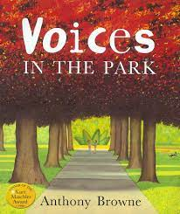 | A Christmas Carol  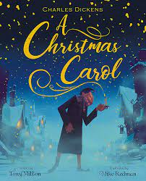
Fiction | Stories with familiar settings  Write a version of the story based on a fifth character who has been observing the characters. | Stories with historical settings – own ‘ghost’ that visits
Non-fiction | Recounts  A recount of our visit to the park? | Biography – Charles Dickens
Poetry |  | Creating images
Hook ideas | Go to the park – what can we observe?
Short burst writing opportunities | Speech  Thought bubbles  Character description  Setting description  Spine poem – in the park I see… | Diary  Arguments/debates  Character description  Character profiles  Settings  Comparing settings past/present
Texts to enrich learning

Wider curriculum writing opportunities (if apt)
Bredbury 50 things links

 | Spring Term – Year 4
 | Spring 1 | Spring 2
 | Writing skills focus:  - Write a narrative with a clear structure, setting, character and plot.  - Use appropriate nouns and pronouns to support cohesion  - Make improvements to my writing by changing grammar and vocab to improve consistency.  - Use fronted adverbials of place, time and manner (including the use of a comma) | Writing skills focus:  - Make improvements to my writing by changing grammar and vocab to improve consistency.  - Use apostrophes for omission and possession.  - Secure the use of punctuation in direct speech.
 | Genre focus  Fiction: Science fiction  Non-fiction: Newspaper report  Poetry: | Genre focus  Fiction:  Non-fiction: Explanation text  Poetry: Shape poetry and calligans
Core text | Lights on cotton rock  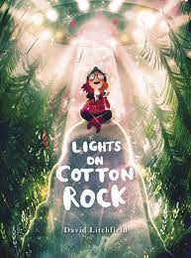 | Until I met Dudley  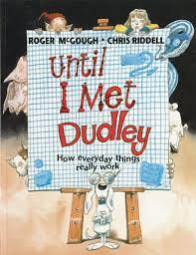
Fiction | Science fiction
Non-fiction | Newspaper report | Explanation text
Poetry |  | Shape poetry and calligans
Hook ideas
Short burst writing opportunities | Character emotions  Direct speech  Indirect speech  Questions  Interviews | Letters  Formal vs informal  Cause and effect  Instruction writing
Texts to enrich learning
Wider curriculum writing opportunities (if apt)
Bredbury 50 things links

 | Summer Term – Year 4
 | Summer 1 | Summer 2
 | Writing skills focus:  - Begin to open paragraphs with topic sentences and organize around a theme.  - Endings are developed and close the narrative appropriately, relating to the beginning.  - Use expanded noun phrases with modifying adjectives. | Writing skills focus:  - Use adverbs and prepositions to express time, place and cause.  - Build cohesion within paragraphs through coordinating and subordinating conjunctions.  - Use fronted adverbials of place, time and manner (including the use of a comma)
 | Genre focus  Fiction: Playscripts  Non-fiction: Persuasive texts  Poetry: Poetic style | Genre focus  Fiction: Stories from other cultures  Non-fiction: Information texts  Poetry:
Core text | Worst witch  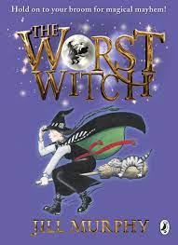 | 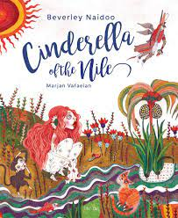  Cinderella of the Nile
Fiction | Playscripts | Stories from other cultures
Non-fiction | Persuasive writing | Information text about Egypt
Poetry | Poetic style – Blackout poetry
Hook ideas
Short burst writing opportunities | Character description  Setting description  Recipe  Slow writing | Character description  Setting description  Comparing settings  Hot seating  Note taking
Texts to enrich learning

Wider curriculum writing opportunities (if apt)
Bredbury 50 things links

